**STRIKE GALAXY ATTACK-CHICKEN INVADERS**

**CONTENTS**

**1. Game Description:**

**2. Config**

***2.1. Admob***

***2.2. Unity Ads***

***2.3. Leaderboard ( Android) & Game Center( iOS)***

***2.4. IAP( In-Apps Purchase)***

***2.5. Time Reward and FreeCoins with Unity Ads***

**3. How to Resin**

**4. How to edit Waves/ Add more Waves / Add more level**

*4.1. How to create,edit a Wave in this game*

*4.2. Detail example*

*4.3. Add More Wave in level*

*4.4. Add More Level*

**5.Note:**

**6.Important note when building iOS**

***--------------------------------------------------------------------------------------------------------***

**1. Game Description:** **(Back to top)**

***1.1.Engine and component:***

1.1.1. Unity 5.6.3f1,Build with Mac OS 10.13- Xcode 9.2

1.1.2. GooglePlayGamesPlugin-0.9.39a

1.1.3. Google Mobile Ads Unity Plugin v3.13.1

1.1.4. Unity Ads v 2.2.1 (The latest version is June 2, 2018)

1.1.5. Unity IAP v1.19.0 (The latest version is June 2, 2018)

*\*All have been integrated into the project!You don't need to import anything else!*

***1.2. Cross platform (Googleplay, iTunes..etc)***

**2. Config** **(Back to top)**

***2.1. Admob***

*In Unity Editor:*

*2.1.1. Go* ***Assets*** *->* ***ChickenInvaders****->****Scenes****-> "****Main****" Scene.*

*2.1.2. In "****Main****" scene, find "****Admob****" object in Hierarchy tab.*

*2.1.3. Select "****Admob****" object,* ***insert*** *your admob id here->Done!*

***2.2. Unity Ads***

*In Unity Editor:*

*2.2.1. Window->* ***Service*** *->Settings->* ***Unlink****,****Rename*** *project.*

*2.2.2. Window-> Service ->****Goto Dashboard****->* ***Find your UnityAds id****, Copy it.*

*2.2.3. In Unity Editor ,Go Assets -> ChickenInvaders->Scenes-> "****Main****" Scene.*

*2.2.4. In "Main" scene, find "****UnityAds****" object in Hierarchy tab.*

*2.2.5. Select " UnityAds " object,* ***insert*** *your UnityAds id here->Done!*

***2.3. Leaderboard ( Android) & Game Center( iOS)***

*\* Android:*

*2.3.1. In Unity Editor, Go File->Build Settings-> Player Settings->* ***Other Settings****-> Identification ->* ***Change "Package Name"****, "Version","Bundle Version Code"*

*2.3.2. Unity Editor, Go File->Build Settings-> Player Settings-> Publishing Settings->* ***Create New keystore*** *-> fill your information in your keystore*

*2.3.3.* ***Get SHA1 code****:* *Follow these instructions*

[*https://www.youtube.com/watch?v=aakXkUY6MYU*](https://www.youtube.com/watch?v=aakXkUY6MYU)

*2.3.4. In Google Console Developer:*

*- Open "****Game Service****" tab-> "****Add New Game****" ->* ***Link Apps*** *-> Copy and Paste* ***"Package Name"*** *(Create in step 2.3.1) -> Continue Next Step -> Copy And Paste* ***SHA1 code*** *(Get in step 2.3.3)*

*- Click in* ***Leaderboards*** *->* ***Add new leaderboard*** *(Currently there are 3 leaderboards in this project:* ***High Score****,* ***Unlock Maps*** *and* ***Total Coins-*** *Open* ***LeaderboardController****.cs to more information- You can use them or create your own leaderboards)*

*- Get* ***resources*** *(XML file), Copy it*

*2.3.5. Back in Unity Editor: Go Window-> Google Play Games ->Setup -> Android setup-> Paste* ***resources*** *file in correct blank*

*2.3.6. In "****Main****" scene, find "* ***LeaderBoard****" object in Hierarchy tab -> Insert your leaderboard id ->Done!*

*\* iOS:*

*- Open* ***LeaderboardController****.cs-> Copy leaderboard string*

*- Go Developer.apple.com -> Create provisioning profile*

*- Go iTunes Connect -> Create new game ->... -> Features->* ***Game Center*** *->* ***Create leaderboard*** *-> paste* ***leaderboard string*** *in first step ->Save -> Done!*

***2.4. IAP( In-Apps Purchase)***

- *Open Purchase.cs ->Change your product id (Creat on Google Play  
Console or Itune Connect). You can change the price of IAP packages in this script.  
*With Google Play Console, you have to upload apk file, then creat items product id  
(Tip: create a list of items product id, after uploading the file for publish,creat it on  
Google Play Console).  
* You do not have to change anything in Purchase.cs when switch between android  
and iOS. It works on both Android and iOS.  
*You must turn on IAP in services of Unity ( In Unity Editor ,Window -  
>Sevices(Turn on* IAP *included Turn On* Analytics!*))*

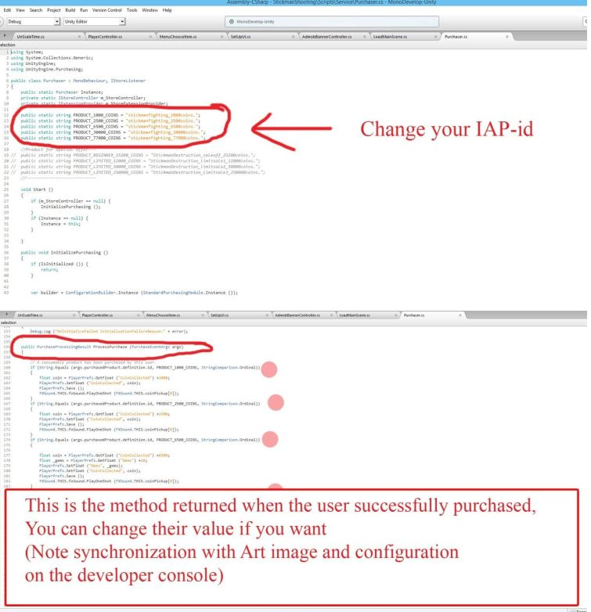

***2.5. Time Reward and FreeCoins with Unity Ads***

*\*Time Reward:*

*-In "****Main****" scene, find "* ***DailyRewardController****" object in Hierarchy tab -> Change time to get reward coins (Hours,Minutes,Seconds). For information you can open DailyRewardController.cs*

*\***FreeCoins:*

*-In "****Main****" scene, find "* ***FreeCoinController****" object in Hierarchy tab -> Change time to get reward coins (Hours,Minutes,Seconds), note that: Users will only be able to watch up to 10 Unity videos during the above period. For information you can open DailyRewardController1.cs & FreeCoinRewardUI.cs*

**3. How to Resin**  **(Back to top)**

*3.1.UI*

*All GUI images can be found in: Assets-> ChickenInvaders ->* *SourcesImage ->* *UI . They are arranged in the order of their screens and function names, which are named according to the principle of Screen Order_Scene Name_Function Name. Example The Adventure button on the Home screen is named 1Home_Adventure.*

*3.2. Player character,Enemies,Item & Effects*

*3.2.1. Image: All image of them you can find in: Assets-> ChickenInvaders ->* *SourcesImage-> Effect,Main Bullet*

*3.2.2. Prefabs: All prefabs of Player,enemy,item,effects in : Assets-> ChickenInvaders ->* *Prefabs*

***\*You can drop them into the Hierarchy tab and change the parameters of sprite, animation or partical for them. Note "Apply" these prefabs after the change.***

***4. How to edit Waves/ Add more Waves / Add more level***

*4.1. How to create,edit a Wave in this game*

*4.1.1 Create a grid in the format: Row x Column:33x19. Points on the path of grid are listed under the name of the Row.Column no. For example, the second point in row 1, named 1.2 (where: 1 is the row name, 2 is the column name of that row)*

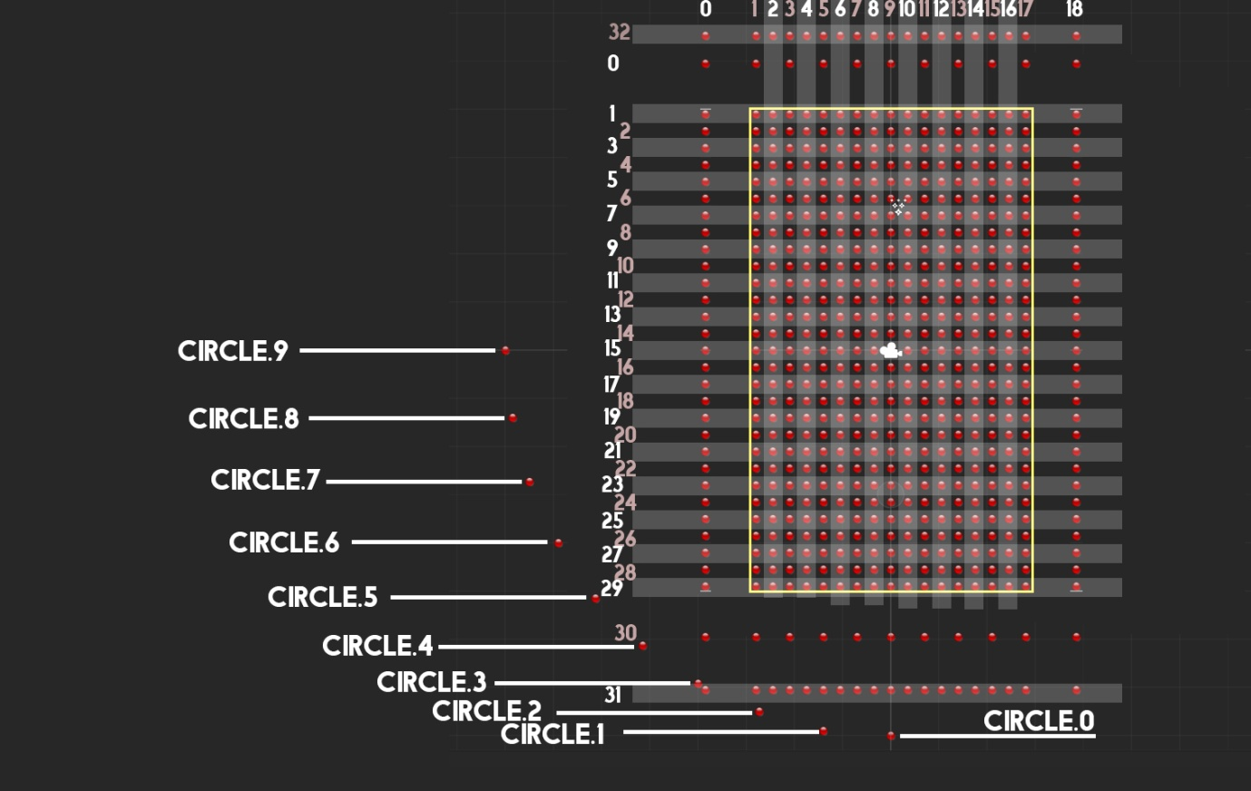

*4.1.2 The chicken will move on the selection point on this grid*

*4.2. Detail example*

*\*To make a chicken move same the " wave1" of "level1" in this game (Play wave 1 in level 1 of this game to see it) do the following*

*-Step1:* *Spawn the first chicken to move along the "Waypoints" as shown in figure, from position 17.18-> 17.16-> 6.16-> 6.3 (number1)*

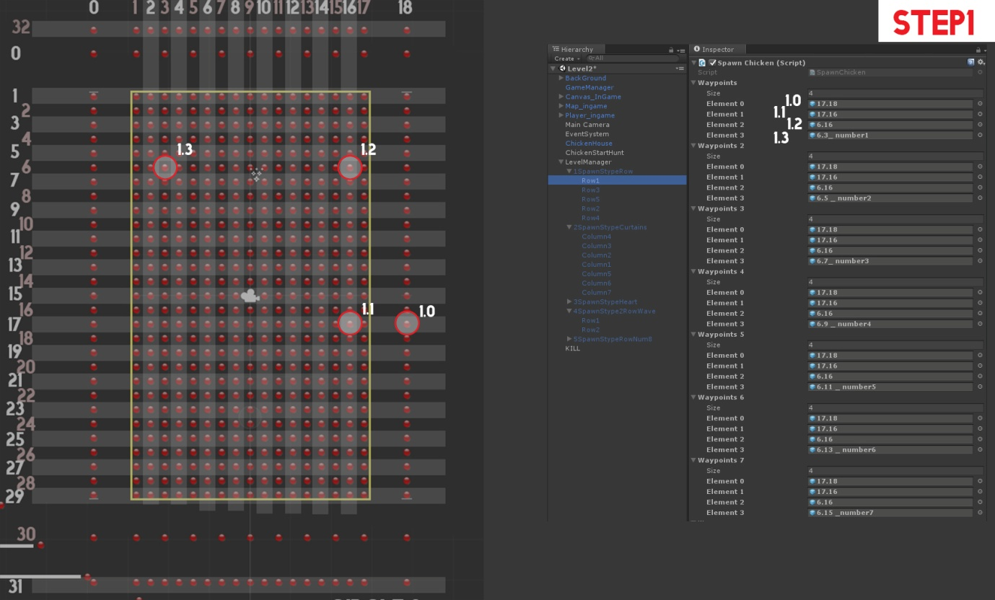

*-Step2:* *Spawn the second chicken to move along the "Waypoints" as shown in figure, from position 17.18-> 17.16-> 6.16-> 6.5 (number1)*

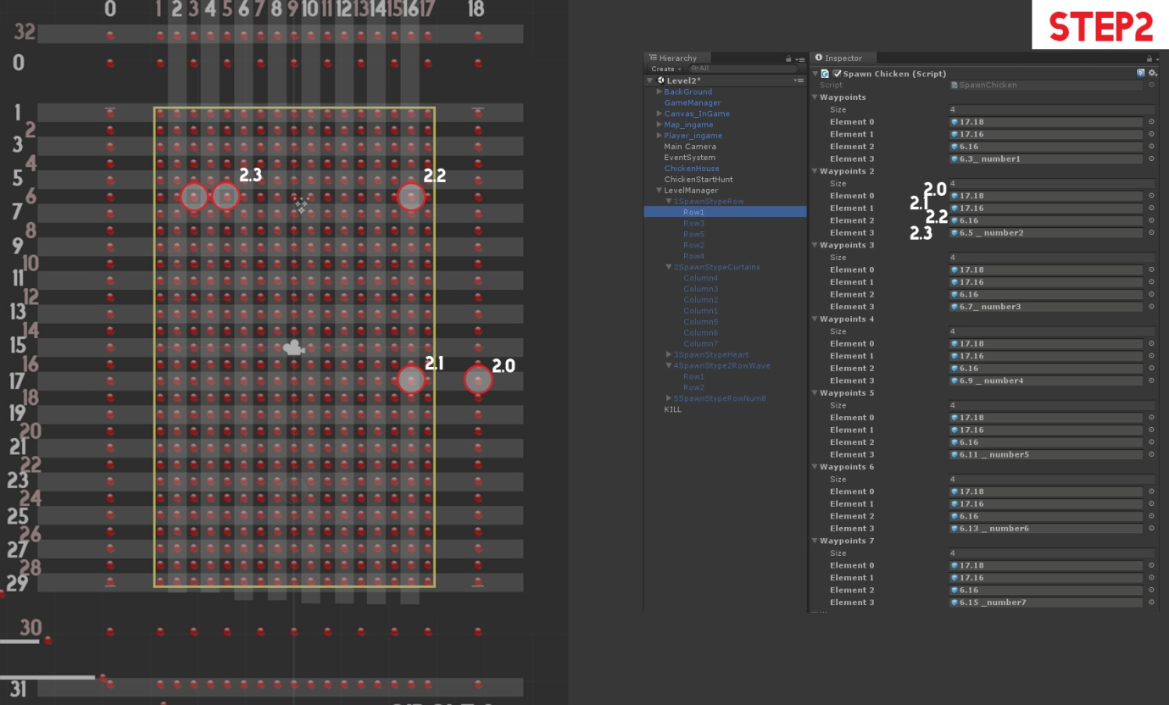

*-Step3 to Step7 keep going the same way as the Waypoints3 to Waypoints7 to spawn chicken and create the first row (Row1) as shown in the picture.*

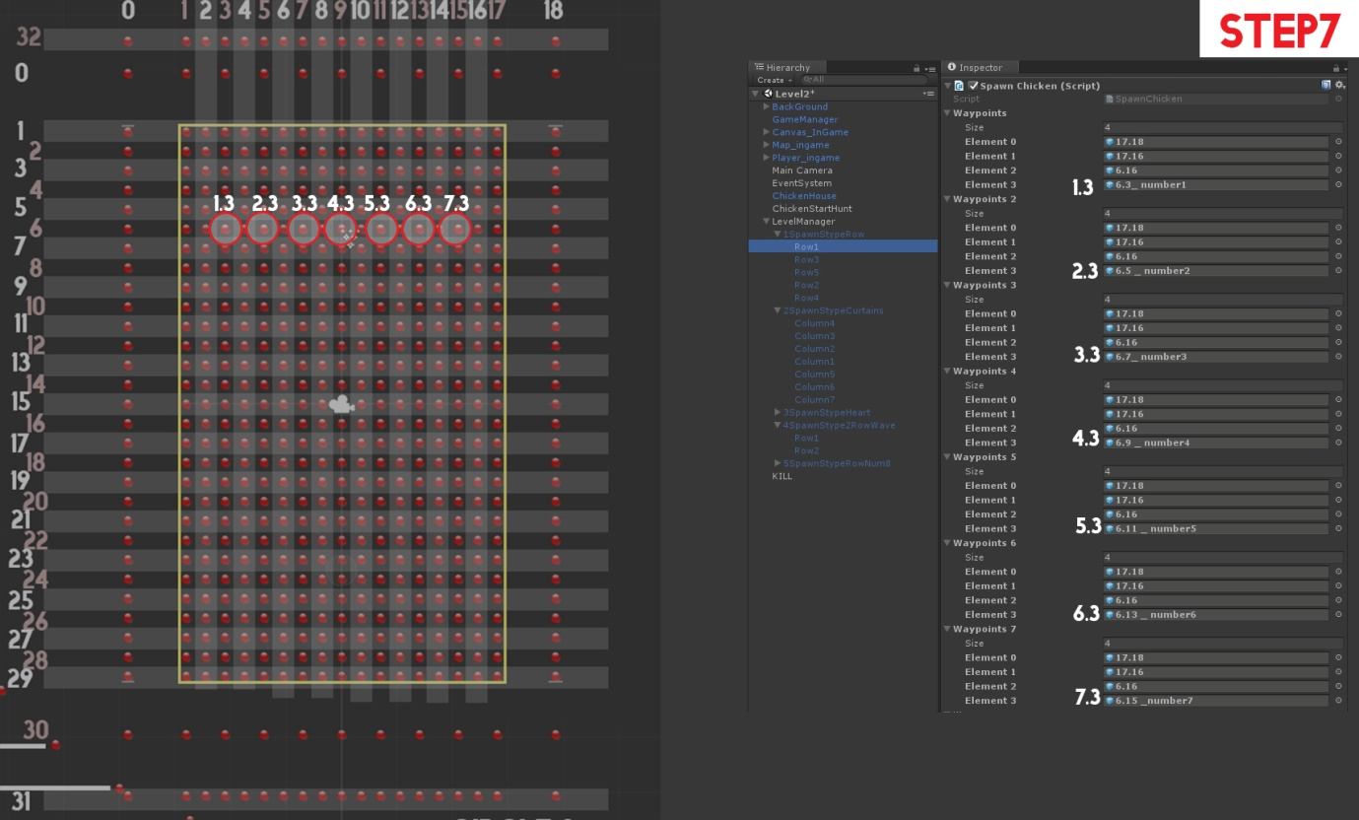

***\*Important parameters***

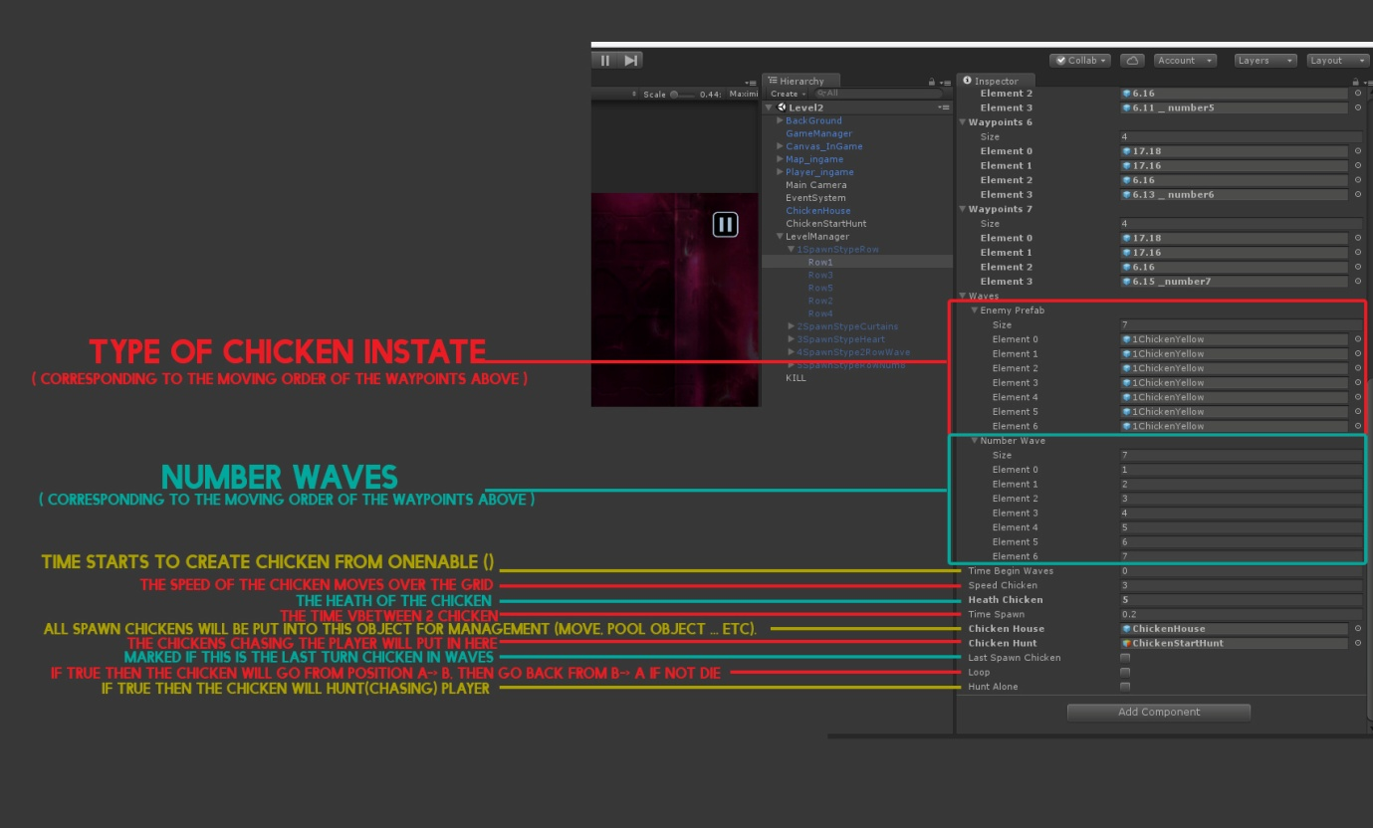

*4.3. Add More Wave in level*

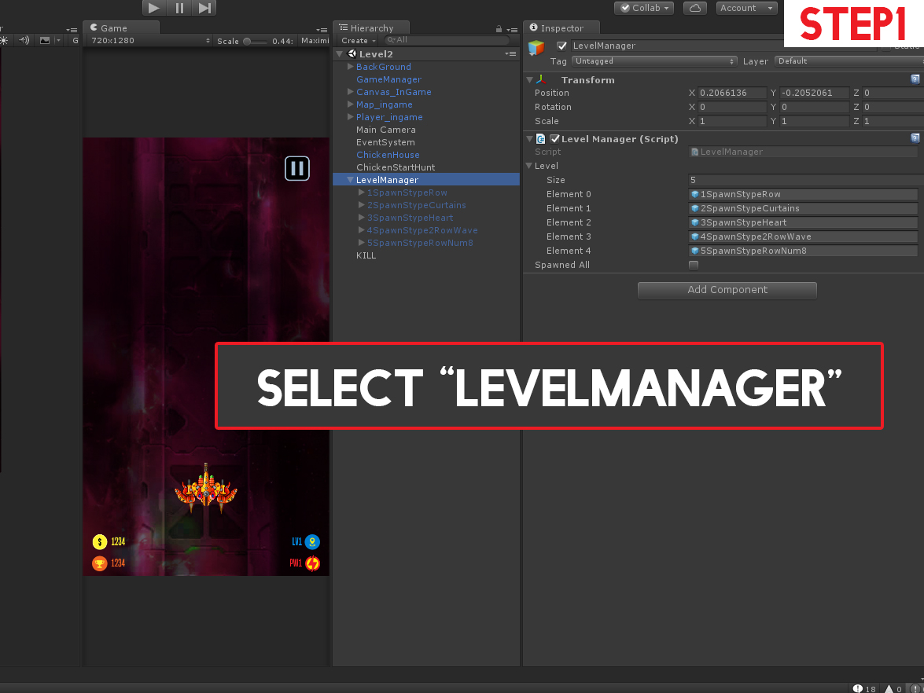

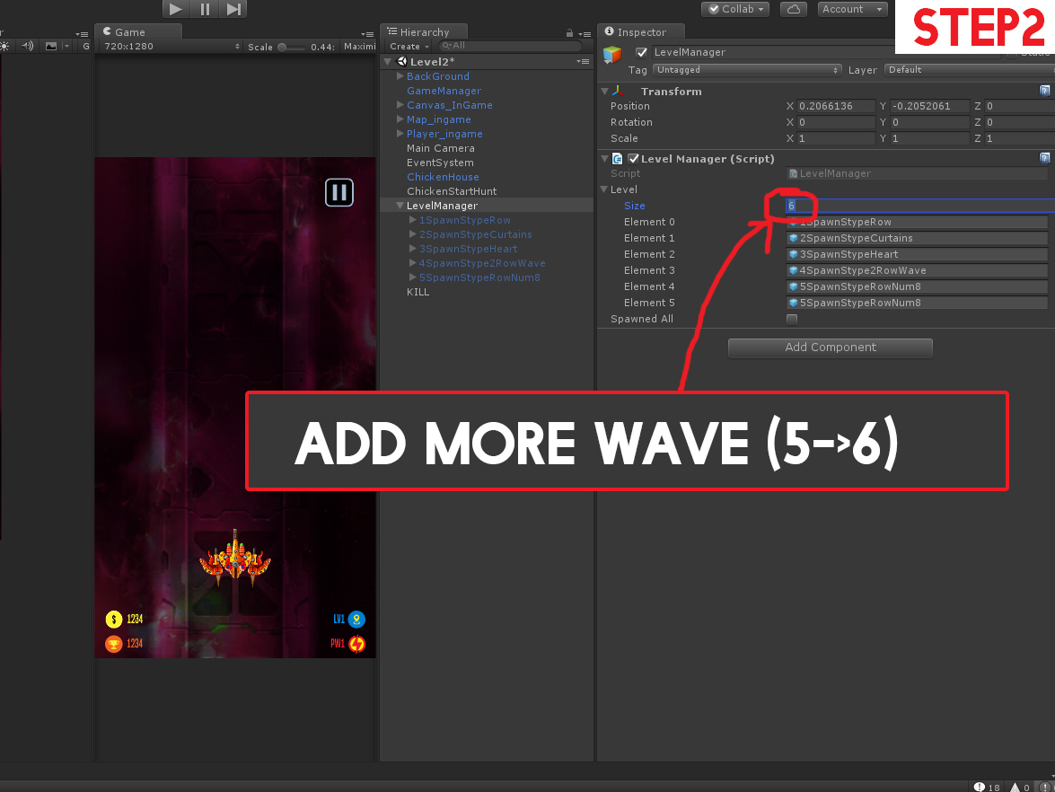

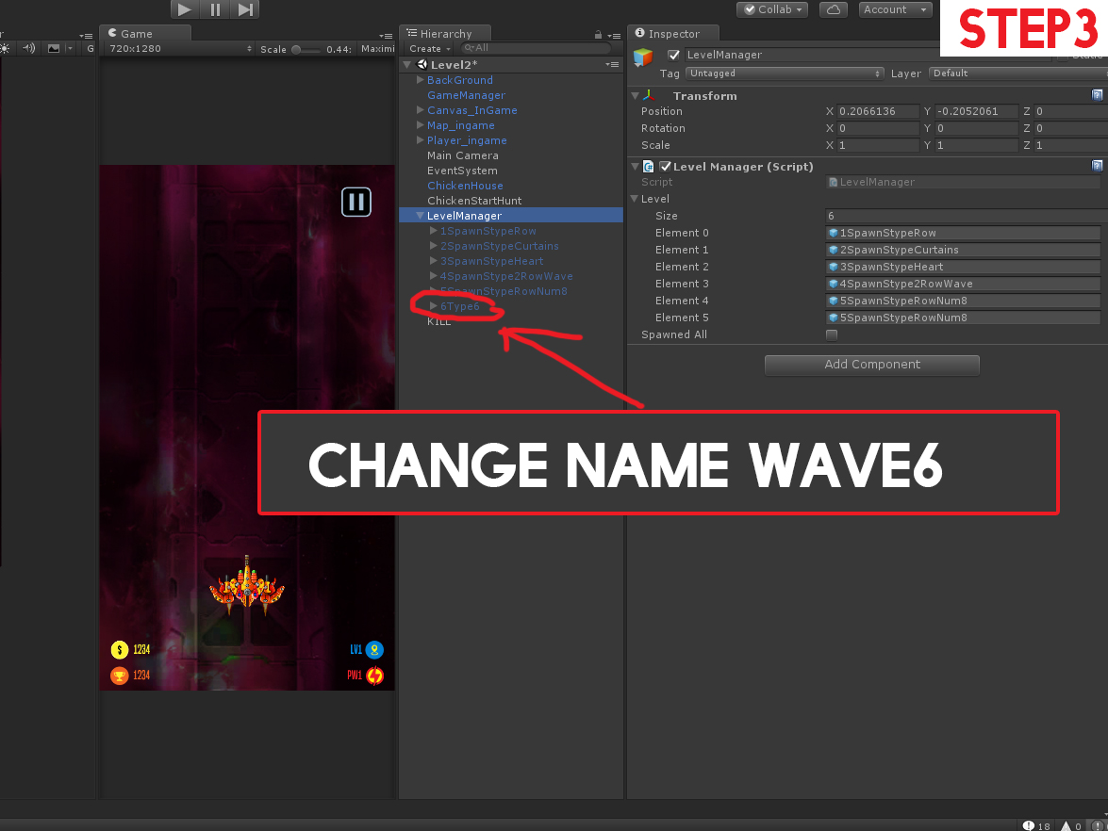

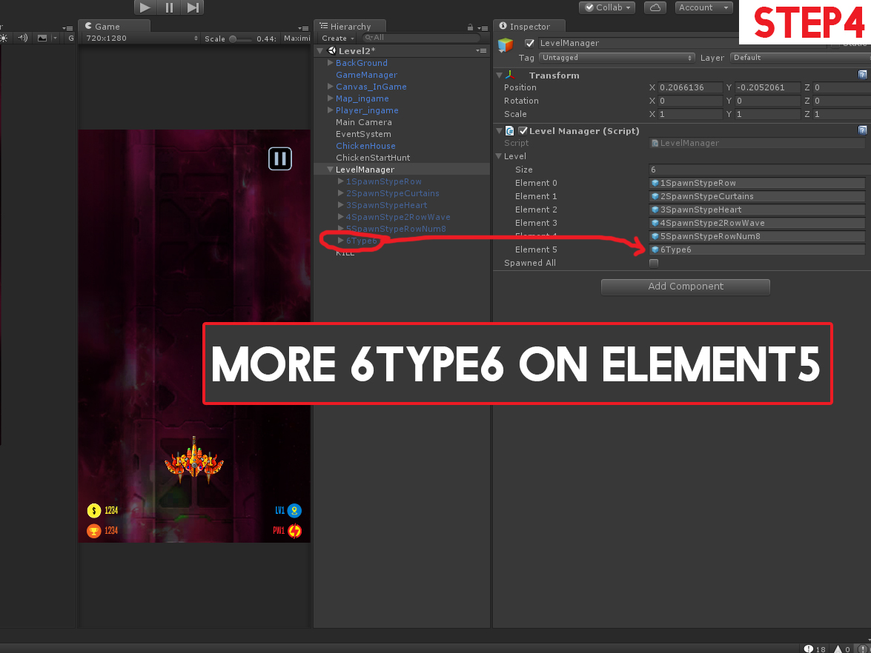

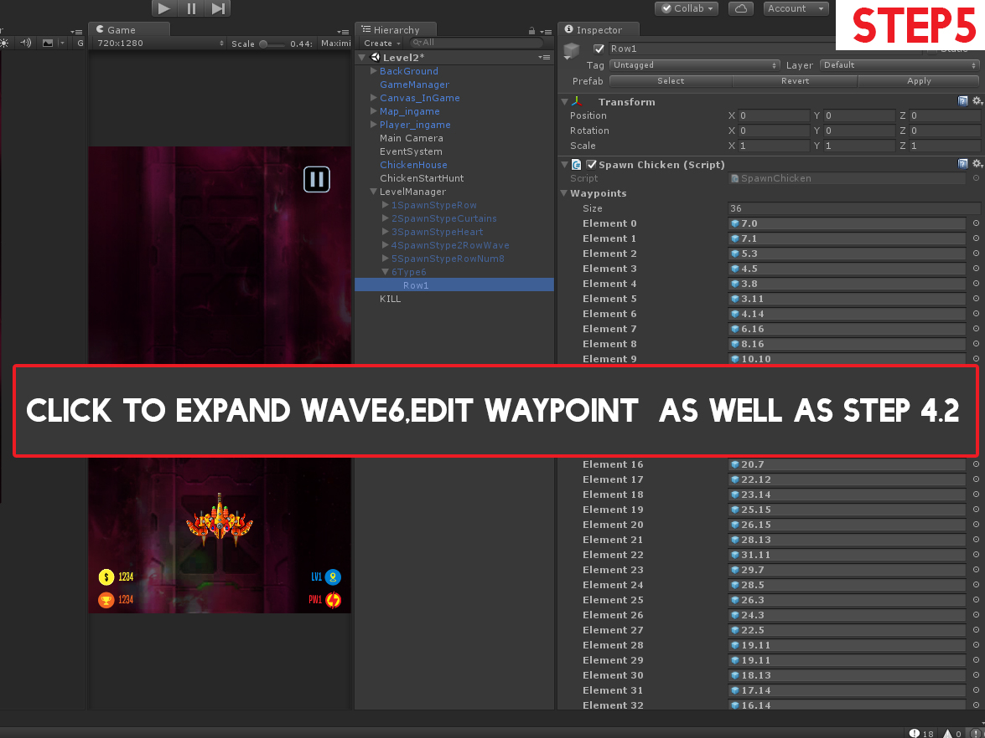

*4.4. Add More Level*

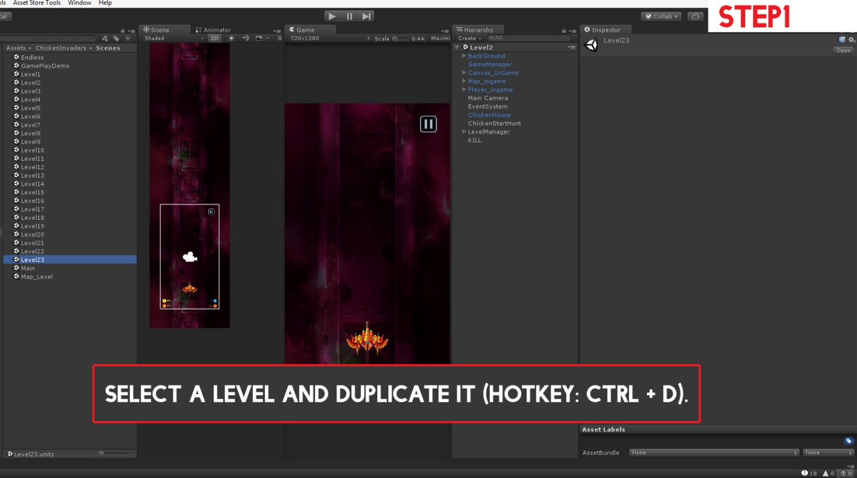

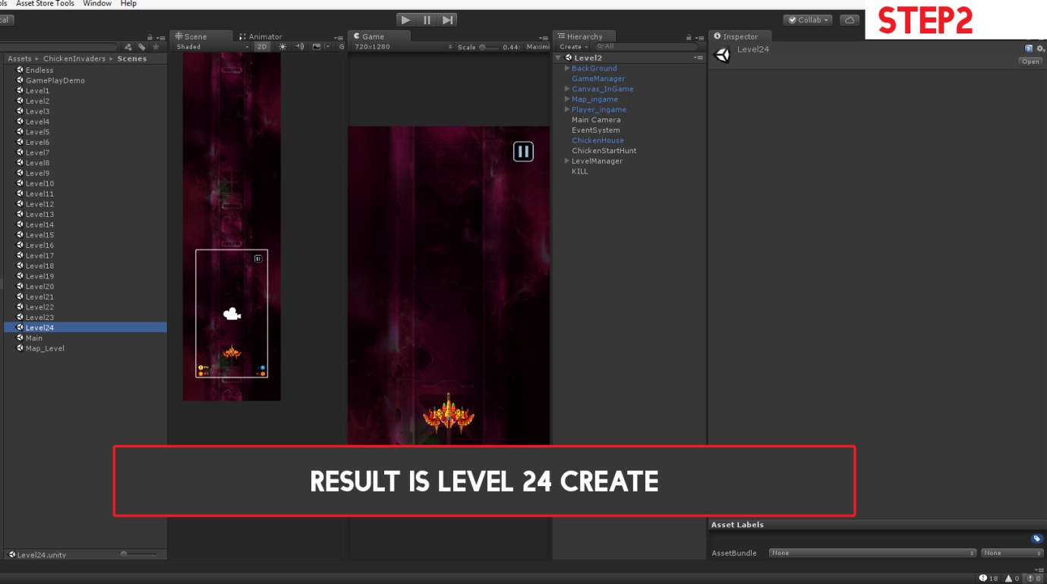

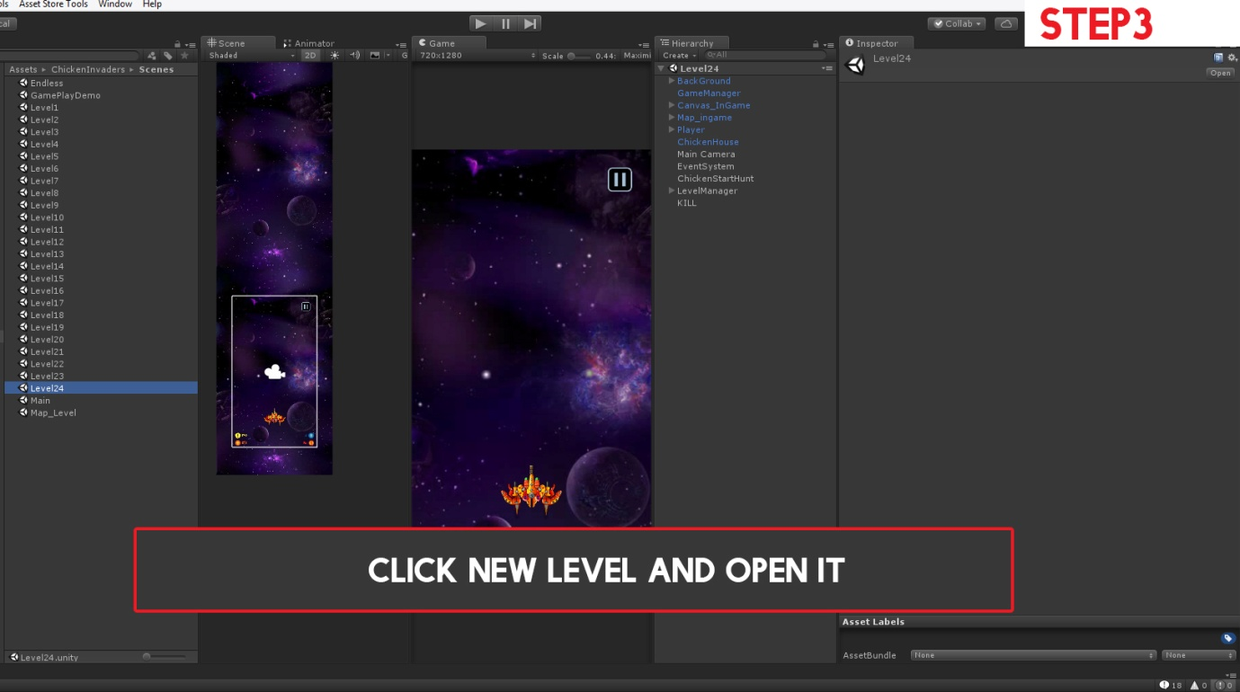

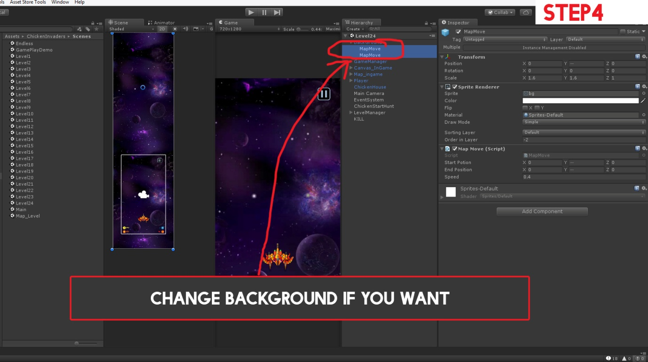

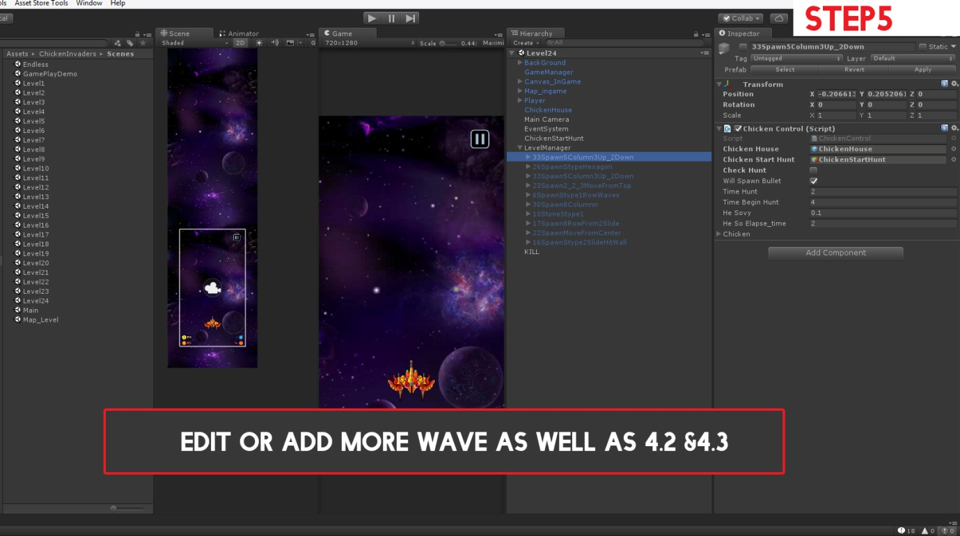

*-Step 6: The config steps on the editor do the following video:*

[*https://drive.google.com/file/d/1aHY1mAlFCarYyYIIx1EgXPIi2HAaPl-X/view*](https://drive.google.com/file/d/1aHY1mAlFCarYyYIIx1EgXPIi2HAaPl-X/view)

[*https://drive.google.com/file/d/1d1bNNefxdeP0ccPB8PAEO1inEpZHFDGG/view*](https://drive.google.com/file/d/1d1bNNefxdeP0ccPB8PAEO1inEpZHFDGG/view)

***5.Note:*** **(Back to top)**

*-1. Do not leave these two objects = null, always select Chicken House and Chicken Start Hunt when creating new waves or edit waves*

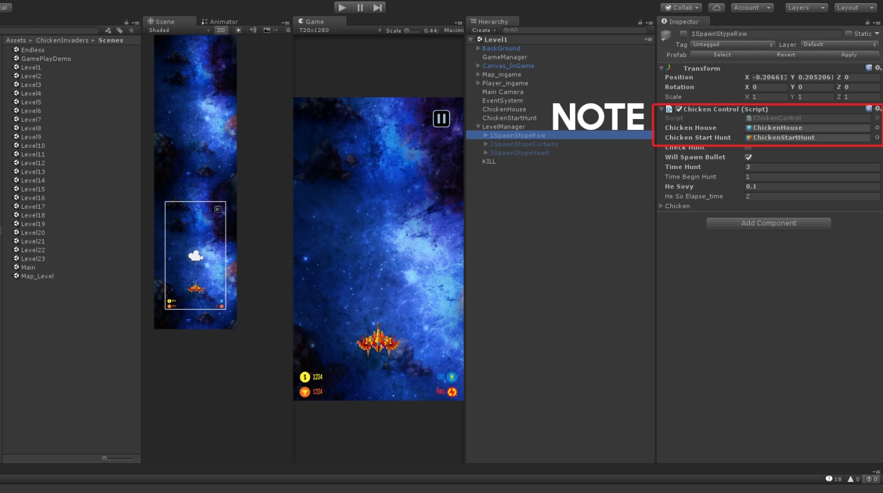

*-2.*

*- Check hunt = true means that the whole shape will in turn chase chickens*

*-Will Spawn bullet = true means that the whole shape will spawn bullets*

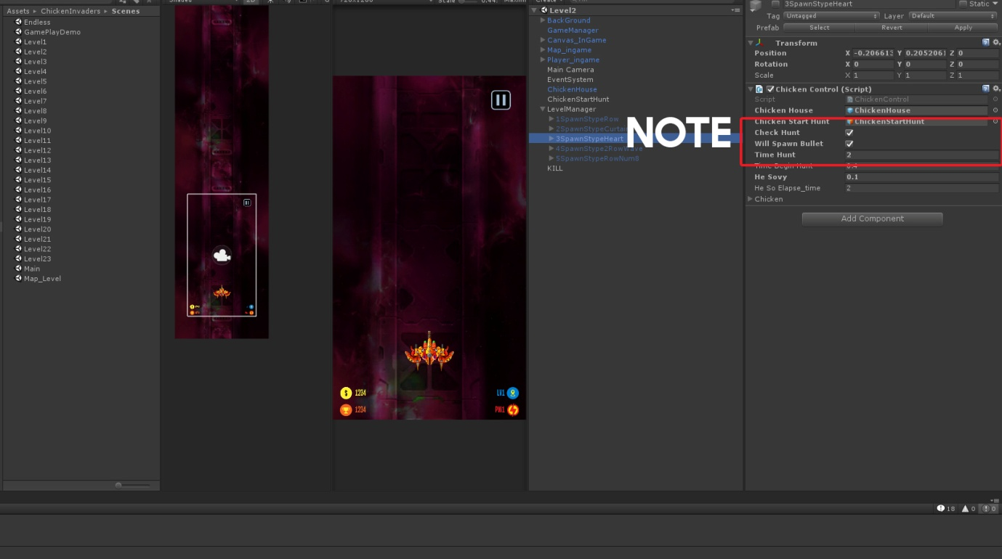

*-3. In any shape created, always mark the last wave created by this shape*

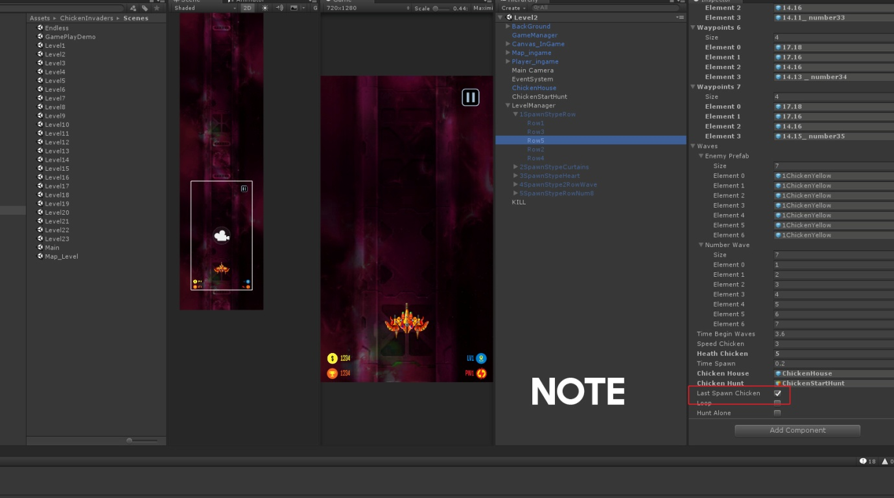

*-4. All scripts of this project you can find in : Assets->Scripts. They are sorted by specific category. Read them if you want to learn more*

*-5.* *To find the method of displaying Unity Ads and Admob Ads. In Monodev, select "Search" -> "File in files" -> Search by keyword "// ads"*

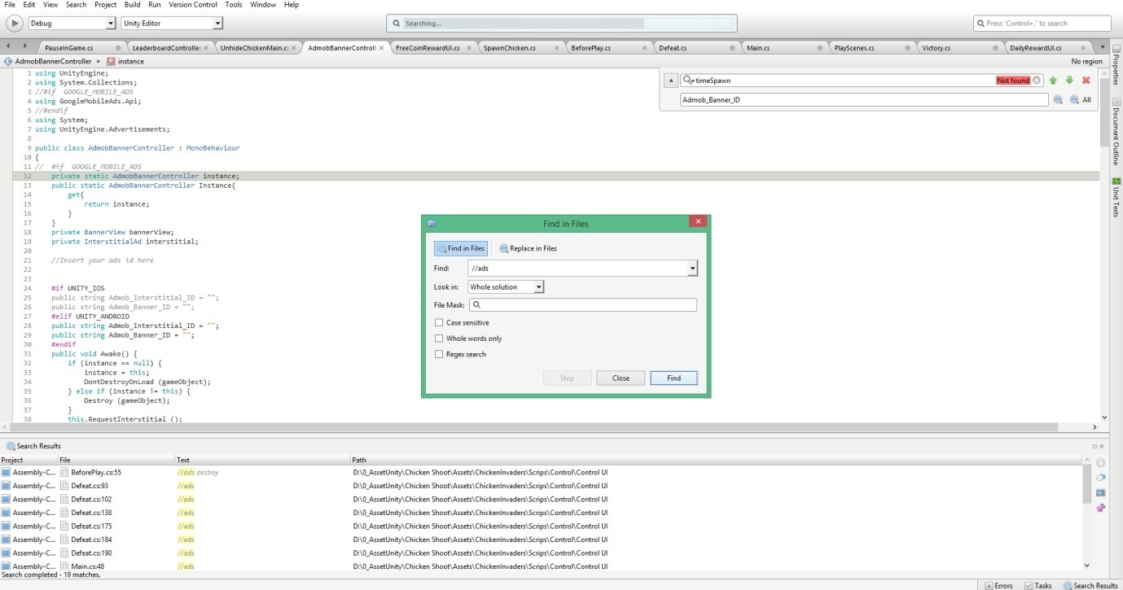

*-6.*

*PlayerPrefs.Getint("Level"); Save current level selected*  
*PlayerPrefs.Getint("HighScore_"+ ...); Save score level ...*  
*PlayerPrefs.Getint("TotalLevelDone"); Save level maps unlock*  
*PlayerPrefs.Getint("Bought"); =0: Not Buy // = 1: Buy Bullet   // = 2: Buy power  // = 3: Buy Heath*  
*PlayerPrefs.Getint("GOLD"); Amount Coins of player*

-7. Important note when building iOS **(Back to top)**

The original project was to be in Android build mode. After you build apk for Android, then you want to build iOS then please follow these instructions to avoid errors:

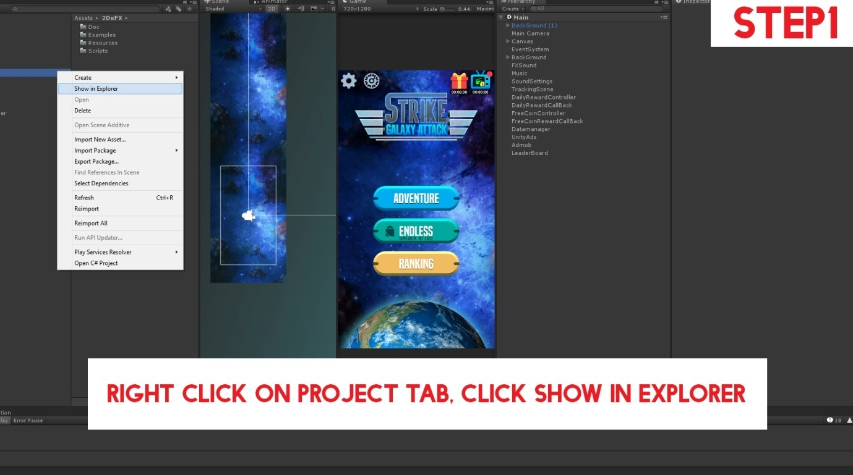

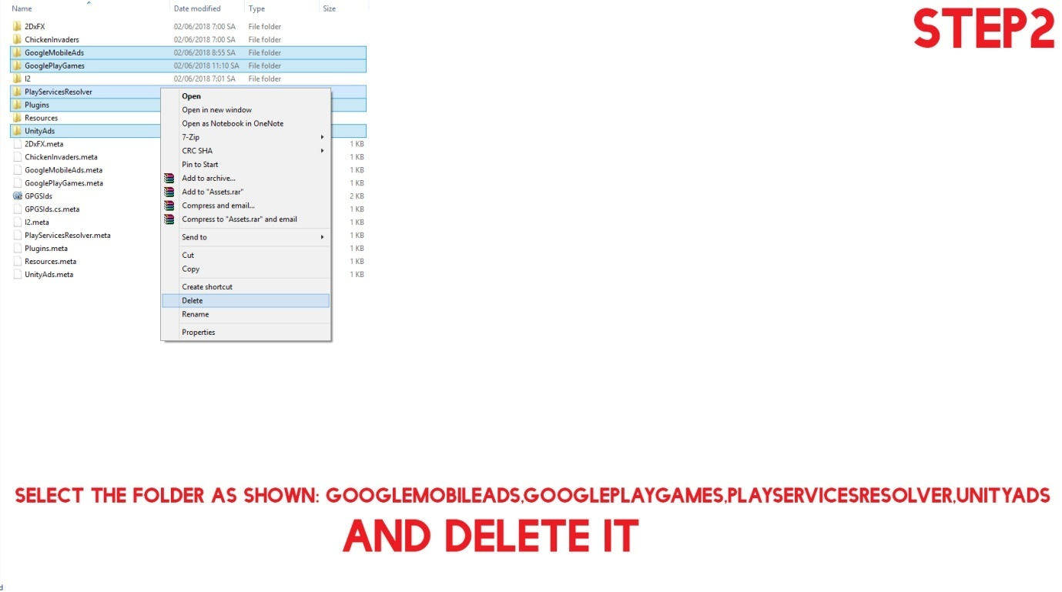

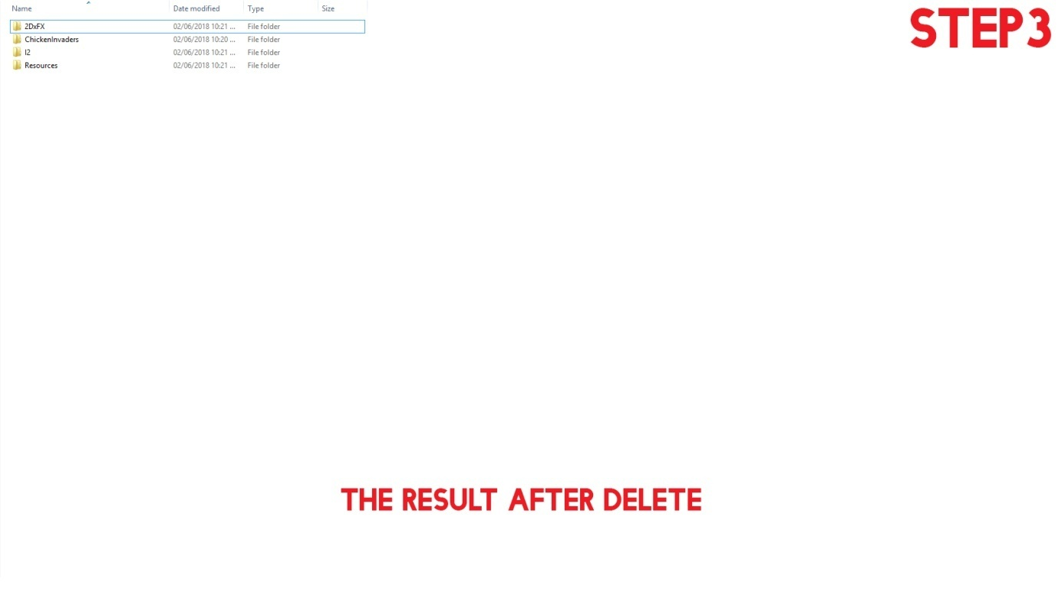

Step4 files: <https://drive.google.com/file/d/1JjVwqYPiZfXB27pKn9tKu1dIRD-eKhxS/view>

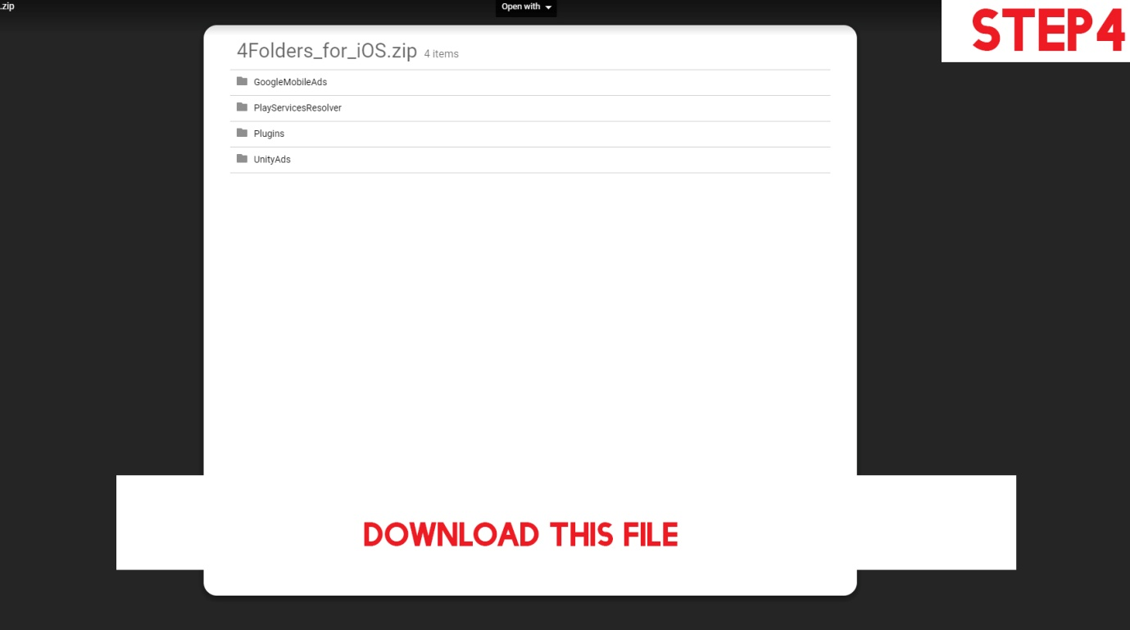

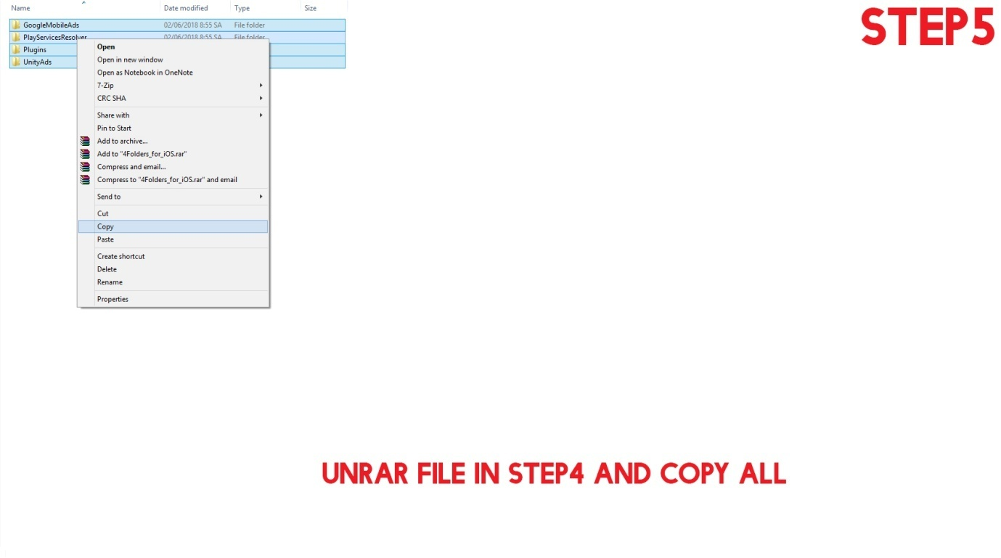

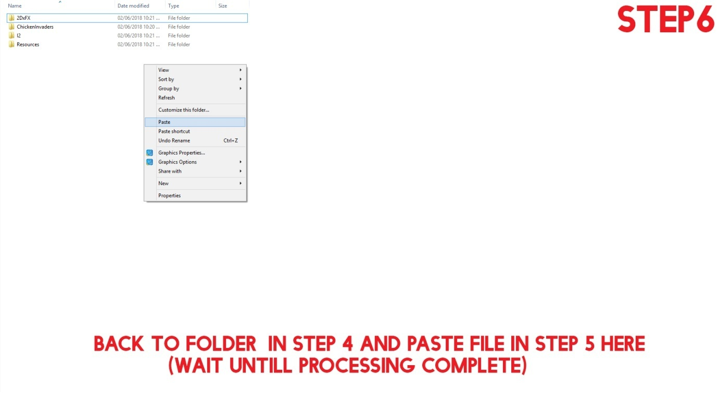

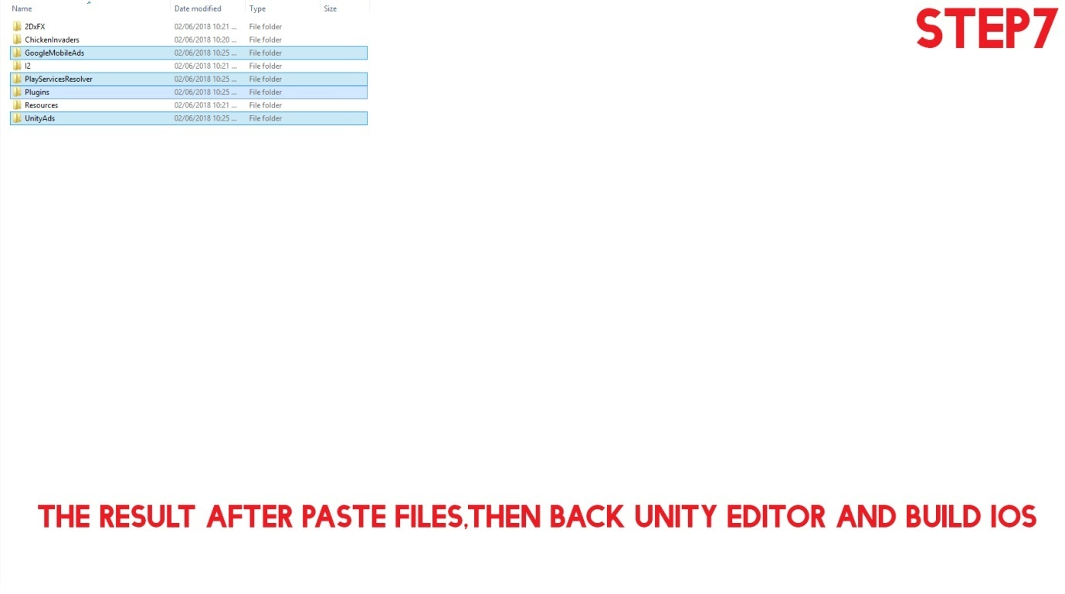 **(Back to top)**